Remote Desktop Observer
The project report submitted in partial fulfillment of the requirements
for the award of
Master of computer applications
By
V.USHA BALA
(50619006)
Carried out at
LOTUS WIRELESS TECHNOLOGIES PVT LTD.
(Visakhapatnam)
Under the esteemed guidance of
VIJAY
Project Leader

DEPARTMENT OF COMPUTER SCIENCE
VISAKHA INSTITUTE FOR PROFESSIONAL STUDIES
(Affiliated To Andhra University)
Visakhapatnam
(2005-2008)
VIPS
Phone: 0891-2537794
2794725 6529066
Fax : 0891- 2537793
VISAKHA INSTITUTE FOR PROFESSIONAL STUDIES
(Affiliated To Andhra University)
College Address:
kapuluppada
Visakhapatnam urban agglomeration
Visakhapatnam-531 163

d
Society address:
55-1-24
J.r.nagar, venkojipalem
Visakhapatnam-530022

CERTIFICATE FOR STUDENTS WHO HAD DONE PROJECT
IN THE INDUSTRY/ORGANIZATION

This is to certify that it is bonafied record of the dissertation work entitled “CONTENT BASED OBJECT RETRIEVAL” done by V.USHA BALA a student of master of computer application in the Department Of Computer Science, VISAKHA INSTITUTE FOR PROFESSIONAL STUDIES, VISAKHAPATNAM during the period (2007-2008) in the partial fulfillment of the requirements for the award of degree of Master Of Computer Application. This work is not submitted to any university for any degree/diploma. This work is carried out in LOTUS WIRELESS TECHNOLOGIES PVT LTD., Visakhapatnam.

(VIJAY) (Sarmishtha das)
internal guide Head Of The Department

Certificate

This is to certify that V.USHA BALA student of final year; MCA in VISAKHA INSTITUTE FOR PROFESSIONAL STUDIES with enrollment no 50619026 has done project work in our organization under the guidance of our project leader Mr. VIJAY, FIRSTMAN SOFTWARE SOLUTIONS, Visakhapatnam.

Period : Dec ′27 to April ′07
project title : REMOTE DESKTOP OBSERVERsoftware used : .NET using c#

We wish his all success in her future endeavors.
For LOTUS WIRELESS TECHNOLOGIES PVT LTD.,

Mr. MANINDER SINGH
(MANAGING DIRECTOR)

ACKNOWLEDGEMENT

The satisfaction that accompanies the successful of any task would be incomplete without a mention of the people, who made it possible and whose guidance and encouragement crown all the efforts with success.

I would like to take this opportunity to express my deep sense of gratitude and extend my best wishes to all people, who have guided, inspired and motivated me during this project and it gives me immense pleasure to acknowledge their co-operation.

It gives me immense pleasure to thank my internal guide
Mr. VIJAY who has been encouraging and kind enough to help me at times need.
I would like to render my deep sense of gratitude to Mrs. Sarmishtha das for her kindness and guidance without which this project would not have been completed.

I am very grateful to all my faculty and friends for their constructive suggestion ones, excellent help and personal attention to do this project in an effective manner. Finally I would like to thank my family members for their continuous support and encouragement

(V.USHA BALA)

DECLARATION

I, V.USHA BALA, MCA student of Visakha Institute for Professional Studies hereby declare that the project report entitled “CONTENT BASED OBJECT RETRIEVAL” submitted by me is entirely original and has been carried out in LOTUS WIRELESS TECHNOLOGIES PVT LTD., Visakhapatnam. This report being submitted in partial fulfillment to final semester MCA course in my own and is not submitted any other college/university or published at any time before.

Station : Visakhapatnam

Date of submission :
(V.USHA BALA)

ABSTRACT

Remote Desktop Observer is a applicable to a network of computers in a remote location. It is a tool developed to capture the desktop screen of the remote clients and sends it to the administrative system. The screen can be captured by copying the image of that screen on to a “clipboard”, ready to paste into any program.

The Windows clipboard is a convenient tool you can use to copy or move information from one place to another. To use clipboard, simply select the text, image, or other item you want to copy or move to another place. After the screen is captured, it is copied to the clipboard. Then, the same screen is selected from the clipboard and pasted on the administrator’s desktop. In this way, the administrator can view the desktop screen of the remote client without informing him.

This process is repeated according to the administrator’s given interval. The administrator can store the remote client’s desktop screen if he/she required. He can either send some alert to the remote client system as warning for their illegal works or he can even inform about a message as alert to the remote client. The administrator can either send a group or individual alert to the clients.

When the administrator finds the client performing an illegal action, then he wants the client by sending him a message. After some time, if he still sees the client continuing that illegal task, the administrator will look the desktop of the client. Later the desktop can be unlocked on request from the client.

CONTENTS
- INTRODUCTION PAGE NO
1.1. ABOUT ORGANIZATION
1.2. INTRODUCTION TO ENVIRONMENT
1.2.1. HARDWARE USED
1.2.2. SOFTWARE USED
1.3. SOFTWARE PROFILE
- SYSTEM REQUIREMENT SPECIFICATION
2.1. INTRODUCTION
2.2.GENRAL DESCRIPTION
- SYSTEM ANALYSIS DOCUMENT
3.1.PROBLEM STATEMENT
3.2.EXISTING SYSTEM
3.3.PROPSED SYSTEM
3.3.1.SCOPE OF THE SYSTEM
3.3.2.NEED AND JUSTIFICATION FOR PROPOSED SYSTEM
3.3.3.FUNCTIONAL REQUIREMENTS
3.3.4.NON- FUNCTIONAL REQUIREMENTS
3.3.5.USER INTERFACE
3.3.6.SYSTEM MODELS
3.3.6.1.SCENARIOS
3.3.6.2.USECASES
3.3.7.FEASBILITY STUDY
3.3.8.PERFORMANCE CHARACTERISTICS
- SYSTEM DESIGN
4.1. INTRODUCTION TO UML DIAGRAMS
4.2.UML DIAGRAMS
4.2.1. USE CASE DIAGRAMS
4.2.2. Class Diagrams
4.2.3. SEQUENCE DIAGRAMS
4.2.4. STATE CHART DIAGRAMS
4.2.5.ACTIVITY DIAGRAMS
4.3.DATA DICTIONARY
4.4.DATABASE DESIGN
- SYSTEM VERIFICATION AND VALIDATION
- IMPLEMENTATION
- TESTING
7.1.TYPES OF TESTING
7.2.TEST CASES
- SYSTEM MAINTAINANCE AND FUTURE ENHANCEMENT
- CONCLUSION
- BIBLIOGRAPHY
- APPENDIX
11.1 SAMPLE SCREENS
11.2 SAMPLE REPORTS
- USER MANUAL

INTRODUCTION

INTRODUCTION

FEASIBILITY STUDY

Feasibility study is the high level capsule version of the entire requirement analysis process. The objective of feasibility study is to determine whether the proposed system can be developed with available resources.
There are three steps to be followed in determining the feasibility of the proposed system.

- Technical Feasibility
- Operational Feasibility
- Economic Feasibility

Technical Feasibility:
Technical Feasibility is a study of function performance and constraints that may affect the ability to achieve an acceptable system. It is concerned with hardware and software feasibility. In this study we analyze whether the proposed system can be developed using existing technology. When new technology is required, we analyze the likelihood that it can be developed? The organization for which the system is to be developed is not yet computerized. Hence there is a requirement for new hardware and software technology for the deployment of proposed system. As per client requirements the system to be developed should have high response because of fast changing nature of the information, programming productivity, reliability, security, scalability, integration and availability.

If the feasibility study is to serve as a decision document, it must answer three key questions:
- Are there a new and a better way to do the job that will benefit the user?
- What are the costs and savings of the alternatives?
- What is recommended?

The most successful system projects are not necessarily the biggest or most visible in a business, but rather those that truly meets the user expectations. More projects fail due to inflated expectations than for any other reason. While preparing the project the above factors have been kept in view.

Economic Feasibility:

Economic feasibility is an evaluation of development cost weighed against the ultimate income or benefit from the developed system or product. This includes the evaluation of all incremental costs and benefits expected if proposed system is implemented. Costs-benefit analysis, which is to be performed during economic feasibility, delineates costs for project development and weighs them against benefits of the system. If benefits outweighs costs, then the decision is made to design and implement the system. Other wise further justifications or alterations in the proposed system will have to be made if it is to have a chance of being acceded to. This is an on going effort that improves in accuracy at each phase of the system life cycle.

Operational Feasibility:
Operational feasibility determines whether the proposed system satisfies the user objectives and can be fitted in to current operations of the organization. The proposed system “Project Monitoring” can be justified as operationally feasible basing on the following.

    - The methods of processing and presentation are completely
    - Acceptable by the clients because they meet all the user and
    - Client requirements.
    - The clients have been involved during the preparation of requirement analysis and design process.
    - The system will certainly satisfy the user objectives and it will also enhance their capability.

SYSTEM REQUIREMENTS

Hardware Requirements (minimum):

Processor : Pentium III or above

RAM : 256MB or above

Hard disk : 40GB or above.

Monitor : Color Monitor

Software Requirements:

Operating system : Windows XP/2000 Professional

IDE : C#.Net

FUNCTIONAL REQUIREMENTS:

Functional requirements specify which output should be produced from the given input. They describe the relationship between the data and the methods to obtain the output. This includes specifying the valid IP address and the desired operation i.e. to be performed on the remote system.

The Administrator should be able to inform the user before performing the terminal operations on the users system. Incase of the user not being available on that system, the administrator can abnormally terminate the system.

- The Administrator should be able to search the files by specifying the valid IP address, drive in which the file has to be searched and also the type file that has to be searched. These files are to be listed in a table. The administrator can be able to download the desired file and can also be able to upload the file.

NON -FUNCTIONAL REQUIREMENTS:

A non-functional requirement in software engineering presents systematic and pragmatic approach to ‘building quality into software systems’. System must exhibit software quality attributes such as accuracy, performance, security and modifiability.

- Response time: Time taken by the user to get output.
- The Remote Desktop Observer system provides user friendly GUI (Graphical User Interface).
- Memory usage: It is total amount of memory used by the system.

UML DIAGRAMS

UML:

Notations enable us to articulate complex ideas succinctly and precisely. For a notation, to enable accurate communication, it must come with a well-defined semantics, it must be well suited for representing a given aspect of a system and it must be well understood among project participants. UML (Unified Modeling Language) provides a spectrum of notations for presenting different aspects of a system and has been accepted as a standard notation.

Brief History:

UML stands for Unified Modeling Language, a modeling language conceived by the Rational Software Corporation and Grady Booch, James Rumbaugh and Ivar Jacobson.UML is simple, extensible and a very expressive visual modeling language. UML is mainly used to model software-intensive systems but is expensive enough to comprehensively model non-software systems. UML can be used to visualize, specify, construct and document the software system being developed. The Object Management Group (OMG) has adopted UML as the standard modeling language.

OVERVIEW OF UML:
UML is a notation resulted from the unification of OMT (Object Modeling Technique) and OOSE (Object Oriented Software Engineering) and provides constructs for a broad range of systems and activities. (Analysis and system design). System development focuses on three different models of the system.

CLASS DESIGN:

Class Diagrams
Class diagrams identify the class structure of a system, including the properties and methods of each class. Also depicted are the various relationships that can exist between classes, such as an inheritance relationship. The Class diagram is one of the most widely used diagrams from the UML specification. Part of the popularity of Class diagrams stems from the fact that many CASE tools, such as Rational XDE, will auto-generate code in a variety of languages, including Java, C++, and C#, from these models. These tools can synchronize models and code, reducing your workload, and can also generate Class diagrams from object-oriented code, for those "code-then-design" maintenance projects.

Notation
The elements on a Class diagram are classes and the relationships between them
Class | Classes are the building blocks in object-oriented programming. A Class is depicted using a rectangle divided into three sections. The top section is the name of the Class. The middle section defines the properties of the Class. The bottom section lists the methods of the class. | 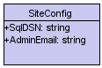
Association | An Association is a generic relationship between two classes, and is modeled by a line connecting the two classes. This line can be qualified with the type of relationship, and can also feature multiplicity rules (e.g. one-to-one, one-to-many, many-to-many) for the relationship.
Composition | If a class cannot exist by itself, and instead must be a member of another class, then that class has a Composition relationship with the containing class. A line with a filled diamond indicates a Composition relationship.
Dependency | When a class uses another class, perhaps as a member variable or a parameter, and so "depends” on that class, a Dependency relationship is formed. A dotted arrow indicates a Dependency relationship.
Aggregation | Aggregations indicate a whole-part relationship, and are known as "has-a" relationships. A line with a hollow diamond indicates an Aggregation relationship.
Generalization | A Generalization relationship is the equivalent of an inheritance relationship in object-oriented terms (an "is-a" relationship). An arrow indicates a Generalization relationship with a hollow arrowhead pointing to the base, or "parent", class.
Consider the example of a veterinary system. Animals served, such as dogs and birds, are tracked along with their owners. The following diagram models a potential solution. Since dogs and birds are "a kind of" animal, we use a Generalization relationship.

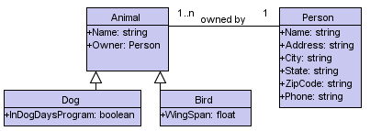

To validate your model, you can apply real-world data into instances of the classes. In fact, there is a diagram for precisely this task, the Object Diagram.

CLASS DIAGRAM

SHAPE

Convert into B/W ()
Is Rect ()
Is Tri ()
Is Cir ()

COLOR

GET INPUT COLORS ()

MULTICOLOR

Get String ()
Get Color String()
Get Database RGB ()
OBJCLS

GetImages ()
GetURLs()
DISPLAY

Get Dis pixels ()
Get RGB ()
Compare RGB ()
AREA

Get XY1 ()
Get XY2 ()
Get XY3 ()
Get XY4 ()
Get XY5 ()
Get XY6 ()

Dependency

VerSer

GetKeyword()
GetCategory()
FindKeyword()
ViewResult()

Generalization

USE CASE MODEL OF THE SYSTEM:

Use Case Diagrams
Use Case diagrams identify the functionality provided by the system (use cases), the users who interact with the system (actors), and the association between the users and the functionality. Use Cases are used in the Analysis phase of software development to articulate the high-level requirements of the system. The primary goals of Use Case diagrams include:
- Providing a high-level view of what the system does
- Identifying the users ("actors") of the system
- Determining areas needing human-computer interfaces
Use Cases extend beyond pictorial diagrams. In fact, text-based use case descriptions are often used to supplement diagrams, and explore use case functionality in more detail.

Graphical Notation
The basic components of Use Case diagrams are the Actor, the Use Case, and the Association.
Actor | An Actor, as mentioned, is a user of the system, and is depicted using a stick figure. The role of the user is written beneath the icon. Actors are not limited to humans. If a system communicates with another application, and expects input or delivers output, then that application can also be considered an actor. | 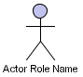
Use Case | A Use Case is functionality provided by the system, typically described as verb object (e.g. Register Car, Delete User). Use Cases are depicted with an ellipse. The name of the use case is written within the ellipse. | 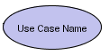
Association | Associations are used to link Actors with Use Cases, and indicate that an Actor participates in the Use Case in some form. A line connecting the Actor and the UseCase depicts associations.

The following image shows how these three basic elements work together to form a use case diagram.

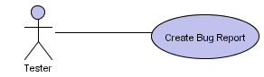

Text Notation
Behind each Use Case is a series of actions to achieve the proper functionality, as well as alternate paths for instances where validation fails, or errors occur. These actions can be further defined in a Use Case description. Because this is not addressed in UML 1.4, there are no standards for Use Case descriptions. However, there are some common templates you can follow, and whole books on the subject writing of Use Case descriptions.
Common methods of writing Use Case descriptions include:
- Write a paragraph describing the sequence of activities in the Use Case
- List two columns, with the activities of the actor and the responses by the system
- Use a template (such as those from the Rational Unified Process or Alistair Cockburn's book, Writing Effective Use Cases) identifying actors, preconditions, post conditions, main success scenarios, and extensions.
Remember, the goal of the process is to be able to communicate the requirements of the system, so use whichever method is best for your team and your organization. Here are examples of a paragraph and template use case description for our Use Case Diagram.

USE CASE DIAGRAM:
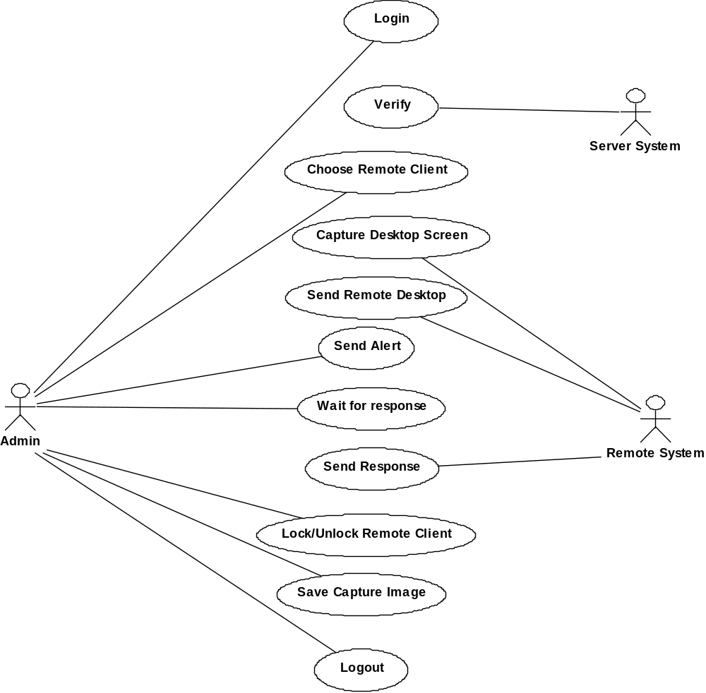

Scenario name: Registration

Actors: User, System

Flow of Control:
      - User will visit the site

      - Fill the registration form

      - System will check the availability for ID

      - Enroll registration details with ID and Password.

SEQUENCE DIAGRAM:

Sequence Diagrams
Sequence diagrams document the interactions between classes to achieve a result, such as a use case. Because UML is designed for object-oriented programming, these communications between classes are known as messages. The Sequence diagram lists objects horizontally, and time vertically, and models these messages over time.

Notation
In a Sequence diagram, classes and actors are listed as columns, with vertical lifelines indicating the lifetime of the object over time.
Object | Objects are instances of classes, and are arranged horizontally. The pictorial representation for an Object is a class (a rectangle) with the name prefixed by the object name (optional) and a semi-colon. | 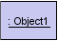
Actor | Actors can also communicate with objects, so they too can be listed as a column. An Actor is modeled using the ubiquitous symbol, the stick figure. | 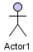
Lifeline | The Lifeline identifies the existence of the object over time. The notation for a Lifeline is a vertical dotted line extending from an object.
Activation | Activations, modeled as rectangular boxes on the lifeline, indicate when the object is performing an action.
Message | Messages, modeled as horizontal arrows between Activations, indicate the communications between objects.

Following is an example of a Sequence diagram, using the default named objects. You can imagine many instances where a user performs an action in the user interface, and the system in turn calls another object for processing.

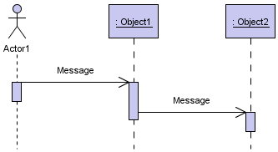

Class diagram

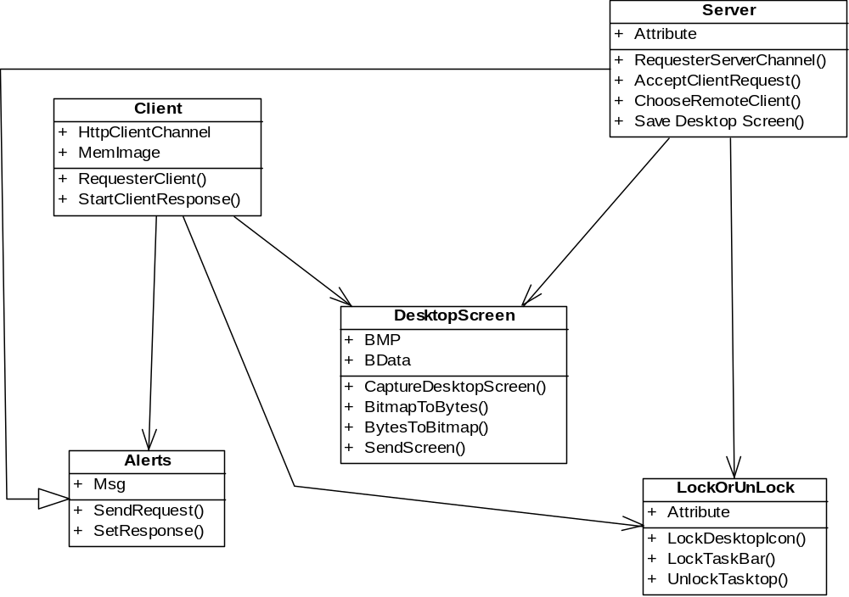

Sequence Diagram

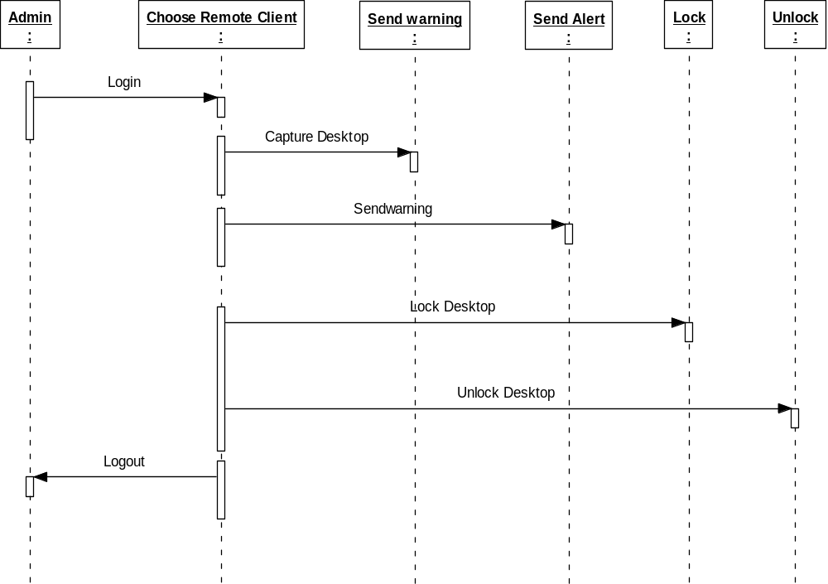

State chart diagram

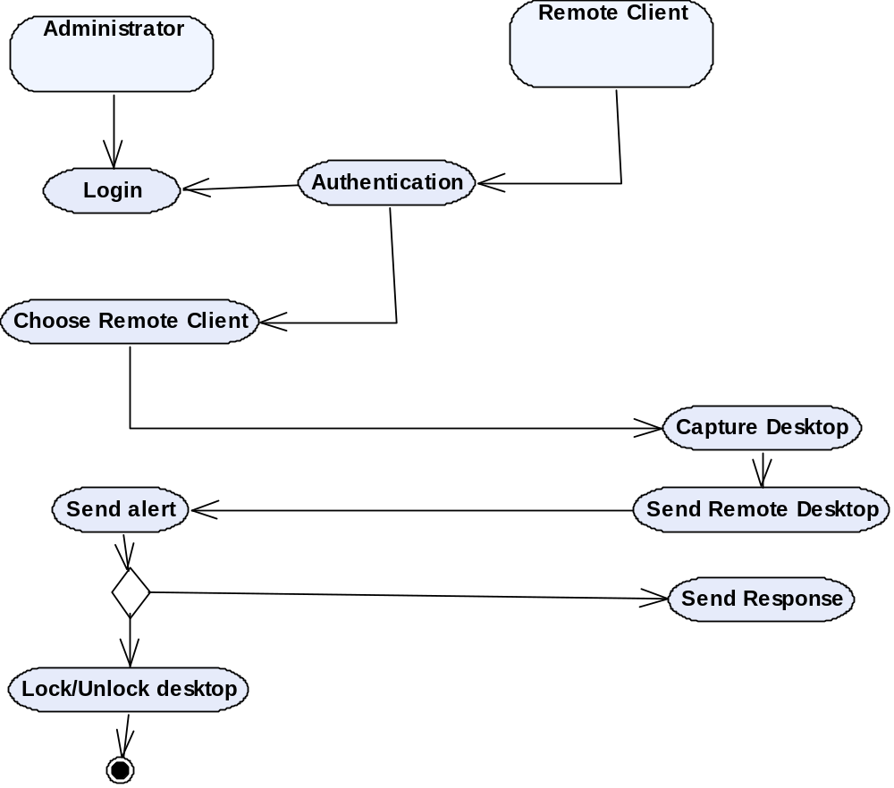

ACTIVITY DIAGRAM

Activity Diagrams
Activity diagrams are used to document workflows in a system, from the business level down to the operational level. When looking at an Activity diagram, you'll notice elements from State diagrams. In fact, the Activity diagram is a variation of the state diagram where the "states" represent operations, and the transitions represent the activities that happen when the operation is complete. The general purpose of Activity diagrams is to focus on flows driven by internal processing vs. external events.

Notation
Activity States | Activity states mark an action by an object. The notation for these states is rounded rectangles, the same notation as found in State chart diagrams. | 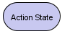
Transition | When an Activity State is completed, processing moves to another Activity State. Transitions are used to mark this movement. Transitions are modeled using arrows. | 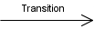
Swim lane | Swim lanes divide activities according to objects by arranging objects in column format and placing activities by that object within that column. Objects are listed at the top of the column, and vertical bars separate the columns to form the swim lanes. | 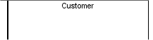
Initial State | The Initial State marks the entry point and the initial Activity State. The notation for the Initial State is the same as in State chart diagrams, a solid circle. There can only be one Initial State on a diagram.

Final State | Final States mark the end of the modeled workflow. There can be multiple Final States on a diagram, and these states are modeled using a solid circle surrounded by another circle.
Synchronization Bar | Activities often can be done in parallel. To split processing ("fork"), or to resume processing when multiple activities have been completed ("join"), Synchronization Bars are used. These are modeled as solid rectangles, with multiple transitions going in and/or out.

Activity Diagram

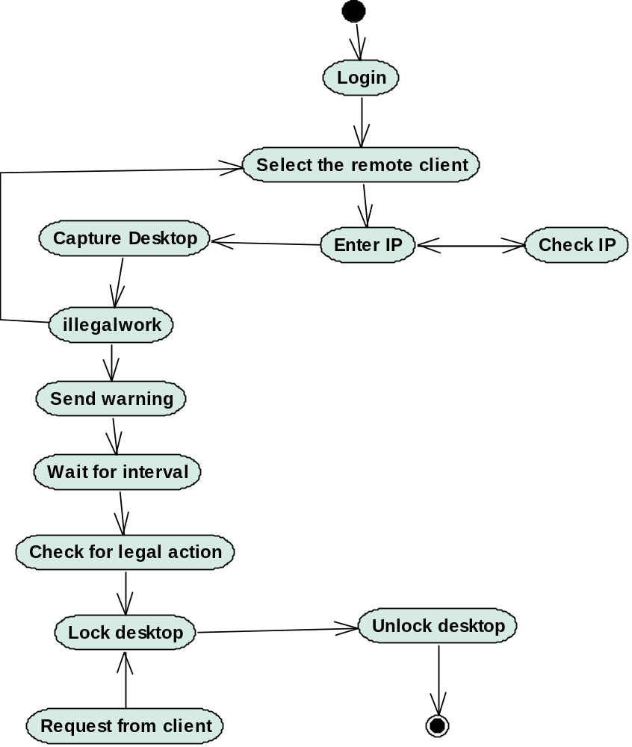

SOFTWARE OVERVIEW

SELECTION OF SPECIFIC S/W:

INTRODUCTION TO .NET:
The .NET Framework is a new computing platform that simplifies application development in the highly distributed environment of the Internet. The .NET Framework is designed to fulfill the following objectives: To provide a consistent object-oriented programming environment whether object code is stored and executed locally, executed locally but Internet-distributed, or executed remotely. To provide a code-execution environment that minimizes software deployment and versioning conflicts. To provide a code-execution environment that guarantees safe execution of code, including code created by an unknown or semi-trusted third party. To provide a code-execution environment that eliminates the performance problems of scripted or interpreted environments. To make the developer experience consistent across widely varying types of applications, such as Windows-based applications and Web-based applications. To build all communication on industry standards to ensure that code based on the .NET Framework can integrate with any other code. The .NET Framework has two main components: the common language runtime and the .NET Framework class library. The common language runtime is the foundation of the .NET Framework. You can think of the runtime as an agent that manages code at execution time, providing core services such as memory management, thread management, and remoting, while also enforcing strict type safety and other forms of code accuracy that ensure security and robustness. In fact, the concept of code management is a fundamental principle of the runtime. Code that targets the runtime is known as managed code, while code that does not target the runtime is known as unmanaged code. The class library, the other main component of the .NET Framework, is a comprehensive, object-oriented collection of reusable types that you can use to develop applications ranging from traditional command-line or graphical user interface (GUI) applications to applications based on the latest innovations provided by ASP.NET, such as Web Forms and XML Web services.

FEATURES OF THE COMMON LANGUAGE RUNTIME (CLR):
The common language runtime manages memory; thread execution, code execution, code safety verification, compilation, and other system services. These features are intrinsic to the managed code that runs on the common language runtime. With regards to security, managed components are awarded varying degrees of trust, depending on a number of factors that include their origin (such as the Internet, enterprise network, or local computer). This means that a managed component might or might not be able to perform file-access operations, registry-access operations, or other sensitive functions, even if it is being used in the same active application. The runtime also enforces code robustness by implementing a strict type- and code-verification infrastructure called the common type system (CTS). The CTS ensures that all managed code is self-describing. The various Microsoft and third-party language compilers generate managed code that conforms to the CTS. This means that managed code can consume other managed types and instances, while strictly enforcing type fidelity and type safety. In addition, the managed environment of the runtime eliminates many common software issues. For example, the runtime automatically handles object layout and manages references to objects, releasing them when they are no longer being used. This automatic memory management resolves the two most common application errors, memory leaks and invalid memory references. The runtime also accelerates developer productivity. For example, programmers can write applications in their development language of choice, yet take full advantage of the runtime, the class library, and components written in other languages by other developers. Any compiler vendor who chooses to target the runtime can do while the runtime is designed for the software of the future; it also supports software of today and yesterday. Interoperability between managed and unmanaged code enables developers to continue to use necessary COM components and DLLs. Finally, the runtime can be hosted by high-performance, server-side applications, such as Microsoft® SQL Server™ and Internet Information Services (IIS). This infrastructure enables you to use managed code to write your business logic, while still enjoying the superior
.
Language Independence
The .NET Framework introduces a Common Type System, or CTS. The CTS specification defines all possible datatypes and programming constructs supported by the CLR and how they may or may not interact with each other. Because of this feature, the .NET Framework supports the exchange of instances of types between programs written in any of the .NET languages. This is discussed in more detail in Microsoft .NET Languages.
Base Class Library
The Base Class Library (BCL), part of the Framework Class Library (FCL), is a library of functionality available to all languages using the .NET Framework. The BCL provides classes which encapsulate a number of common functions, including file reading and writing, graphic rendering, database interaction and XML document manipulation.
Simplified Deployment
Installation of computer software must be carefully managed to ensure that it does not interfere with previously installed software, and that it conforms to increasingly stringent security requirements. The .NET framework includes design features and tools that help address these requirements.
Security
The design is meant to address some of the vulnerabilities, such as buffer overflows, that have been exploited by malicious software. Additionally, .NET provides a common security model for all applications.
Portability
The design of the .NET Framework allows it to theoretically be platform agnostic, and thus cross-platform compatible. That is, a program written to use the framework should run without change on any type of system for which the framework is implemented. Microsoft's commercial implementations of the framework cover Windows, Windows CE, and the Xbox 360. In addition, Microsoft submits the specifications for the Common Language Infrastructure (which includes the core class libraries, Common Type System, and the Common Intermediate Language), the C# language, and the C++/CLI language to both ECMA and the ISO, making them available as open standards. This makes it possible for third parties to create compatible implementations of the framework and its languages on other platforms.

Assemblies

The intermediate CLI code is housed in .NET assemblies. As mandated by specification, assemblies are stored in the Portable Executable (PE) format, common on the Windows platform for all DLL and EXE files. The assembly consists of one or more files, one of which must contain the manifest, which has the metadata for the assembly. The complete name of an assembly (not to be confused with the filename on disk) contains its simple text name, version number, culture, and public key token. The public key token is a unique hash generated when the assembly is compiled, thus two assemblies with the same public key token are guaranteed to be identical from the point of view of the framework. A private key can also be specified known only to the creator of the assembly and can be used for strong naming and to guarantee that the assembly is from the same author when a new version of the assembly is compiled (required to add an assembly to the Global Assembly Cache).

Metadata

All CLI is Self-Describing through .NET metadata. The CLR checks on metadata to ensure that the correct method is called. Metadata is usually generated by language compilers but developers can create their own metadata through custom attributes. Metadata contains information about the assembly, and is also used to implement the reflective programming capabilities of .NET Framework

Security
.NET has its own security mechanism with two general features: Code Access Security (CAS), and validation and verification. Code Access Security is based on evidence that is associated with a specific assembly. Typically the evidence is the source of the assembly (whether it is installed on the local machine or has been downloaded from the intranet or Internet). Code Access Security uses evidence to determine the permissions granted to the code. Other code can demand that calling code is granted a specified permission. The demand causes the CLR to perform a call stack walk: every assembly of each method in the call stack is checked for the required permission; if any assembly is not granted the permission a security exception is thrown.
When an assembly is loaded the CLR performs various tests. Two such tests are validation and verification. During validation the CLR checks that the assembly contains valid metadata and CIL, and whether the internal tables are correct. Verification is not so exact. The verification mechanism checks to see if the code does anything that is 'unsafe'. The algorithm used is quite conservative; hence occasionally code that is 'safe' does not pass. Unsafe code will only be executed if the assembly has the 'skip verification' permission, which generally means code that is installed on the local machine.
.NET Framework uses appdomains as a mechanism for isolating code running in a process. Appdomains can be created and code loaded into or unloaded from them independent of other appdomains. This helps increase the fault tolerance of the application, as faults or crashes in one appdomain do not affect rest of the application. Appdomains can also be configured independently with different security privileges. This can help increase the security of the application by isolating potentially unsafe code. The developer, however, has to split the application into subdomains; it is not done by the CLR.

Memory management
The .NET Framework CLR frees the developer from the burden of managing memory (allocating and freeing up when done); instead it does the memory management itself. To this end, the memory allocated to instantiations of .NET types (objects) is done contiguously from the managed heap, a pool of memory managed by the CLR. As long as there exists a reference to an object, which might be either a direct reference to an object or via a graph of objects, the object is considered to be in use by the CLR. When there is no reference to an object, and it cannot be reached or used, it becomes garbage. However, it still holds on to the memory allocated to it. .NET Framework includes a garbage collector which runs periodically, on a separate thread from the application's thread, that enumerates all the unusable objects and reclaims the memory allocated to them.
The .NET Garbage Collector (GC) is a non-deterministic, compacting, mark-and-sweep garbage collector. The GC runs only when a certain amount of memory has been used or there is enough pressure for memory on the system. Since it is not guaranteed when the conditions to reclaim memory are reached, the GC runs are non-deterministic. Each .NET application has a set of roots, which are pointers to objects on the managed heap (managed objects). These include references to static objects and objects defined as local variables or method parameters currently in scope, as well as objects referred to by CPU registers.[When the GC runs, it pauses the application, and for each object referred to in the root, it recursively enumerates all the objects reachable from the root objects and marks them as reachable. It uses .NET metadata and reflection to discover the objects encapsulated by an object, and then recursively walk them. It then enumerates all the objects on the heap (which were initially allocated contiguously) using reflection. All objects not marked as reachable are garbage.This is the mark phase.Since the memory held by garbage is not of any consequence, it is considered free space. However, this leaves chunks of free space between objects which were initially contiguous. The objects are then compacted together, by using memcpyto copy them over to the free space to make them contiguous again.Any reference to an object invalidated by moving the object is updated to reflect the new location by the GC. The application is resumed after the garbage collection is over.
The GC used by .NET Framework is actually generational.Objects are assigned a generation; newly created objects belong to Generation 0. The objects that survive a garbage collection are tagged as Generation 1, and the Generation 1 objects that survive another collection are Generation 2 objects. The .NET Framework uses up to Generation 2 objects.[ Higher generation objects are garbage collected less frequently than lower generation objects. This helps increase the efficiency of garbage collection, as older objects tend to have a larger lifetime than newer objects. Thus, by removing older (and thus more likely to survive a collection) objects from the scope of a collection run, fewer objects need to be checked and compacted.

Versions
Microsoft started development on the .NET Framework in the late 1990s originally under the name of Next Generation Windows Services (NGWS). By late 2000 the first beta versions of .NET 1.0 were released

The .NET Framework stack.
Version | Version Number | Release Date
1.0 | 1.0.3705.0 | 2002-01-05
1.1 | 1.1.4322.573 | 2003-04-01
2.0 | 2.0.50727.42 | 2005-11-07
3.0 | 3.0.4506.30 | 2006-11-06
3.5 | 3.5.21022.8 | 2007-11-09
A more complete listing of the releases of the .NET Framework may be found on the .NET Framework version list.

.NET Framework 1.0
This is the first release of the .NET Framework. Released on February 13, 2002. Available for Windows 98, NT 4.0, 2000, and XP. Mainstream support by Microsoft for this version ended July 10, 2007, and extended support ends July 14, 2009.^{[17]}

.NET Framework 1.1
This is the first major .NET Framework upgrade. It is available on its own as a redistributable package or in a software development kit, and was published on April 3, 2003. It is also part of the second release of Microsoft Visual Studio .NET (released as Visual Studio .NET 2003). This is the first version of the .NET Framework to be included as part of the Windows operating system, shipping with Windows Server 2003. Mainstream support for .NET Framework 1.1 ends on October 14, 2008, and extended support ends on October 8, 2013. Since .NET 1.1 is a component of Windows Server 2003, extended support for .NET 1.1 on Server 2003 will run out with that of the OS - currently June 30, 2013.

Changes in 1.1 on comparison with 1.0
- Built-in support for mobile ASP.NET controls. Previously available as an add-on for .NET Framework, now part of the framework.
- Security changes - enable Windows Forms assemblies to execute in a semi-trusted manner from the Internet, and enable Code Access Security in ASP.NET applications.
- Built-in support for ODBC and Oracle databases. Previously available as an add-on for .NET Framework 1.0, now part of the framework.
- .NET Compact Framework - a version of the .NET Framework for small devices.
- Internet Protocol version 6 (IPv6) support.
- Numerous API changes.

.NET Framework 2.0
Released with Visual Studio 2005, Microsoft SQL Server 2005, and BizTalk 2006.
- The 2.0 Redistributable Package can be downloaded for free from Microsoft, and was published on 2006-01-22.
- The 2.0 Software Development Kit (SDK) can be downloaded for free from Microsoft.
- It is included as part of Visual Studio 2005 and Microsoft SQL Server 2005.
- Version 2.0 is the last version with support for Windows 2000, Windows 98 and Windows Me.
- It shipped with Windows Server 2003 R2 (not installed by default).

Changes in 2.0 on comparison with 1.1
- Numerous API changes.
- A new hosting API for native applications wishing to host an instance of the .NET runtime. The new API gives a fine grain control on the behavior of the runtime with regards to multithreading, memory allocation, assembly loading and more (detailed reference). It was initially developed to efficiently host the runtime in Microsoft SQL Server, which implements its own scheduler and memory manager.
- Full 64-bit support for both the x64 and the IA64 hardware platforms.
- Language support for generics built directly into the .NET CLR.
- Many additional and improved ASP.NET web controls.
- New data controls with declarative data binding.
- New personalization features for ASP.NET, such as support for themes, skins and webparts.
- .NET Micro Framework - a version of the .NET Framework related to the Smart Personal Objects Technology initiative.

.NET Framework 3.0
.NET Framework 3.0, formerly called WinFX, includes a new set of managed code APIs that are an integral part of Windows Vista and Windows Server 2008 operating systems. It is also available for Windows XP SP2 and Windows Server 2003 as a download. There are no major architectural changes included with this release; .NET Framework 3.0 uses the Common Language Runtime of .NET Framework 2.0.^{[19]} Unlike the previous major .NET releases there was no .NET Compact Framework release made as a counterpart of this version.
.NET Framework 3.0 consists of four major new components:
- Windows Presentation Foundation (WPF), formerly code-named Avalon; a new user interface subsystem and API based on XML and vector graphics, which uses 3D computer graphics hardware and Direct3D technologies. See WPF SDK for developer articles and documentation on WPF.
- Windows Communication Foundation (WCF), formerly code-named Indigo; a service-oriented messaging system which allows programs to interoperate locally or remotely similar to web services.
- Windows Workflow Foundation (WF) allows for building of task automation and integrated transactions using workflows.
- Windows CardSpace, formerly code-named InfoCard; a software component which securely stores a person's digital identities and provides a unified interface for choosing the identity for a particular transaction, such as logging in to a website.

.NET Framework 3.5
Version 3.5 of the .NET Framework was released on November 19, 2007, but it is not included with Windows Server 2008. As with .NET Framework 3.0, version 3.5 uses the CLR of version 2.0. In addition, it installs .NET Framework 2.0 SP1 and .Net Framework 3.0 SP1, which adds some methods and properties to the BCL classes in version 2.0 which are required for version 3.5 features such as Language Integrated Query (LINQ). These changes do not affect applications written for version 2.0, however
As with previous versions, a new .NET Compact Framework 3.5 was released in tandem with this update in order to provide support for additional features on Windows Mobile and Windows Embedded CE devices.
The source code of the Base Class Library in this version has been partially released (for debugging reference only) under the closed-source Microsoft Reference Source License.

Changes since version 3.0
- New language features in C# 3.0 and VB.NET 9.0 compiler
- Adds support for expression trees and lambda methods
- Extension methods
- Expression trees to represent high-level source code at runtime
- Anonymous types with static type inference
- Language Integrated Query (LINQ) along with its various providers
  - LINQ to Objects
  - LINQ to XML
  - LINQ to SQL
- Paging support for ADO.NET
- ADO.NET synchronization API to synchronize local caches and server side datastores
- Asynchronous network I/O API
- Peer-to-peer networking stack, including a managed PNRP resolver
- Managed wrappers for WMI and Active Directory APIs
- Enhanced WCF and WF runtimes, which let WCF work with POX and JSON data, and also expose WF workflows as WCF services.^{[24]} WCF services can be made stateful using the WF persistence model
- Support for HTTP pipelining and syndication feeds
- ASP.NET AJAX is included
- New System.CodeDom namespace.

. NET FRAMEWORK CLASS LIBRARY:
The .NET Framework class library is a collection of reusable types that tightly integrate with the common language runtime. The class library is object oriented, providing types from which your own managed code can derive functionality. This not only makes the .NET Framework types easy to use, but also reduces the time associated with learning new features of the .NET Framework. In addition, third-party components can integrate seamlessly with classes in the .NET Framework. For example; the .NET Framework collection classes implement a set of interfaces that you can use to develop your own collection classes.
As you would expect from an object-oriented class library, the .NET Framework types enable you to accomplish a range of common programming tasks, including tasks such as string management, data collection, database connectivity, and file access. In addition to these common tasks, the class library includes types that support a variety of specialized development scenarios.
For example, you can use the .NET Framework to develop the following types of applications and services:
- Console applications.
- Scripted or hosted applications.
Windows GUI applications (Windows Forms):
C#. NET applications.
Windows services.
For example, the Windows Forms classes are a comprehensive set of reusable types that vastly simplify Windows GUI development. If you write a C#. NET Web Form application, you can use the Web Forms classes.

CLIENT APPLICATION DEVELOPMENT:
Client applications are the closest to a traditional style of application in Windows-based programming. These are the types of applications that display windows or forms on the desktop, enabling a user to perform a task. Client applications include applications such as word processors and spreadsheets, as well as custom business applications such as data-entry tools, reporting tools, and so on. Client applications usually employ windows, menus, buttons, and other GUI elements, and they likely access local resources such as the file system and peripherals such as printers. The managed another kind of client application is the traditional ActiveX control (now replaced by Windows Forms control) deployed over the Internet as a Web page. This application is much like other client applications: it is executed natively, has access to local resources, and includes graphical elements.
In the past, developers created such applications using C/C++ in conjunction with the Microsoft Foundation Classes (MFC) or with a rapid application development (RAD) environment such as Microsoft Visual Basic.
The .NET Framework incorporates aspects of these existing products into a single, consistent development environment that drastically simplifies the development of client applications.
The Windows Forms classes contained in the .NET Framework are designed to be used for GUI development. You can easily create command windows, buttons, menus, toolbars, and other screen elements with the flexibility necessary to accommodate shifting business needs.
For example, the .NET Framework provides simple properties to adjust visual attributes associated with forms. In some cases the underlying operating system does not support changing these attributes directly, and in these cases the .NET Framework automatically recreates the forms. This is one of many ways in which the .NET Framework integrates the developer interface, making coding simpler and more consistent.

SERVER APPLICATION DEVELOPMENT:
Server-side applications in the managed world are implemented through runtime hosts. Unmanaged applications host the common language runtime, which allows your custom managed code to control the behavior of the server. This model provides you with all the features of the common language runtime and class library while gaining the performance and scalability of the host server.

The following illustration show basic network schema with managed code running in different server environment. Servers such as IIS and SQL Server can perform standard operations while your application logic executes through managed code.
SERVER-SIDE MANAGED CODE:

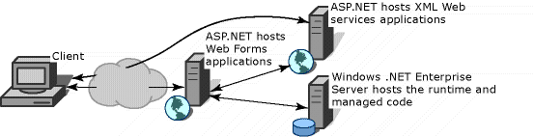
ASP.NET is the hosting environment that enables developers to use the .NET Framework to target Web-based applications. However, ASP.NET is more than just a runtime host; it is a complete architecture for developing Web sites and Internet-distributed objects using managed code. Both Web Forms and XML Web services use IIS and ASP.NET as the NET Framework also provides a collection of classes and tools to aid in development and consumption of XML Web services applications. XML Web services are built on standards such as SOAP (a remote procedure-call protocol), XML (an extensible data format), and WSDL (the Web Services Description Language). The .NET Framework is built on these standards to promote interoperability with non-Microsoft solutions. For example, the Web Services Description Language tool included with the .NET Framework SDK can query an XML Web service published on the Web, parse its WSDL description, and produce C# or Visual Basic source code that your application can use to become a client of the XML Web service. The source code can create classes derived from classes in the class library that handle all the underlying communication using SOAP and XM parsing. Although you can use the class library to consume XML Web services directly, the Web Services
Description Language tool and the other tools contained in the SDK facilitate your development efforts with the .NET Framework. If you develop and publish your own XML Web service, the .NET Framework provides a set of classes that conform to all the underlying communication standards, such as SOAP, WSDL, and XML. Using those classes enables you to focus on the logic of your service, without concerning yourself with the communications infrastructure required by distributed software development.
Finally, like Web Forms pages in the managed environment, your XML Web service will run with the speed of native machine language using the scalable communication of IIS.
NAMESPACES:
Namespaces organize the objects defined in an assembly. These contain multiple namespaces, which can in turn contain other namespaces. Namespaces prevent ambiguity and simplify references when using large groups of objects such as class libraries.
For example, Visual Studio .NET defines the List Box class in the System.Windows.Forms namespace. The following code fragment shows how to declare a variable using the fully qualified name for this class:
Public class Lbox: System.Windows.Forms.ListBox
Visual Studio .NET namespaces address a problem sometimes known as namespace pollution, in which the developer of a class library is hampered by the use of similar names in another library. These conflicts with existing components are sometimes called name collisions. For example, if you create a new class named List Box, you can use it inside your project without qualification. However, if you want to use the Visual Studio .NET List Box class in the same project, you must use a fully qualified reference to make the reference unique. If the reference is not unique, C# .NET produces an error stating that the name is ambiguous. The following code snippet demonstrates how to declare these objects:

' Define a new object based on your List Box class.
Public class LBC: New List Box
' Define a new Windows. Forms List Box control.
Public class MyLB: New System.Windows.Forms.ListBox
The following illustration shows two namespace hierarchies, both containing an object named List Box.
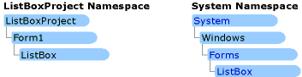

By default, every executable file you create with C#. NET contains a namespace with the same name as your project. For example, if you define an object within a project named ListBoxProject, the executable file, ListBoxProject.exe, contains a namespace called ListBoxProject.
Multiple assemblies can use the same namespace. C#. NET treats them as a single set of names. For example, you can define classes for a namespace called Some Namespace in an assembly named Assemb1, and define additional classes for the same namespace from an assembly named Assemb2.

INTRODUCTION TO ADO.NET:
ADO .NET
Most applications need data access at one point of time making it a crucial component when working with applications. Data access is making the application interact with a database, where all the data is stored. Different applications have different requirements for database access. VB .NET uses ADO .NET (Active X Data Object) as it's data access and manipulation protocol which also enables us to work with data on the Internet. Let's take a look why ADO .NET came into picture replacing ADO.
Evolution of ADO.NET
The first data access model, DAO (data access model) was created for local databases with the built-in Jet engine, which had performance and functionality issues. Next came RDO (Remote Data Object) and ADO (Active Data Object), which were designed for Client Server architectures, but soon ADO took over RDO. ADO was a good architecture but as the language changes so is the technology. With ADO, all the data is contained in a record set object which had problems when implemented on the network and penetrating firewalls. ADO was a connected data access, which means that when a connection to the database is established the connection remains open until the application is closed. Leaving the connection open for the lifetime of the application raises concerns about database security and network traffic. Also, as databases are becoming increasingly important and as they are serving more people, a connected data access model makes us think about its productivity. For example, an application with connected data access may do well when connected to two clients, the same may do poorly when connected to 10 and might be unusable when connected to 100 or more. Also, open database connections use system resources to a maximum extent making the system performance less effective.
Why ADO.NET?
To cope up with some of the problems mentioned above, ADO .NET came into existence. ADO .NET addresses the above-mentioned problems by maintaining a disconnected database access model, which means, when an application interacts with the database, the connection is opened to serve the request of the application and is closed as soon as the request is completed. Likewise, if a database is updated, the connection is opened long enough to complete the Update operation and is closed. By keeping connections open for only a minimum period of time, ADO .NET conserves system resources and provides maximum security for databases and also has less impact on system performance. Also, ADO .NET when interacting with the database uses XML and converts all the data into XML format for database related operations making them more efficient.
The ADO.NET Data Architecture
Data Access in ADO.NET relies on two components: Dataset and Data Provider.
Dataset
The dataset is a disconnected, in-memory representation of data. It can be considered as a local copy of the relevant portions of the database. The Dataset is persisted in memory and the data in it can be manipulated and updated independent of the database. When the use of this Datasets is finished, changes can be made back to the central database for updating. The data in Dataset can be loaded from any valid data source like Microsoft SQL server database, an Oracle database or from a Microsoft Access database.
Data Provider
The Data Provider is responsible for providing and maintaining the connection to the database. A Data Provider is a set of related components that work together to provide data in an efficient and performance driven manner. The .NET Framework currently comes with two Data Providers: the SQL Data Provider which is designed only to work with Microsoft's SQL Server 7.0 or later and the Olden Data Provider which allows us to connect to other types of databases like Access and Oracle. Each Data Provider consists of the following component classes:
The Connection object which provides a connection to the database
The Command object which is used to execute a command
The Data Reader object which provides a forward-only, read only, connected record set
The Data Adapter object which populates a disconnected Dataset with data and performs update
Data access with ADO.NET can be summarized as follows:
A connection object establishes the connection for the application with the database. The command object provides direct execution of the command to the database. If the command returns more than a single value, the command object returns a Data Reader to provide the data. Alternatively, the Data Adapter can be used to fill the Dataset object. The database can be updated using the command object or the Data Adapter.
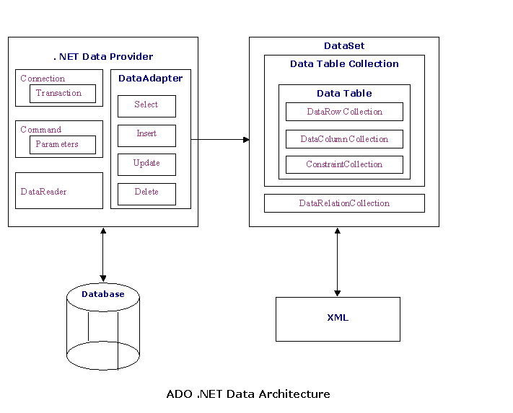

Component classes that make up the Data Providers
The Connection Object
The Connection object creates the connection to the database. Microsoft Visual Studio .NET provides two types of Connection classes: the SqlConnection object, which is designed specifically to connect to Microsoft SQL Server 7.0 or later, and the OleDbConnection object, which can provide connections to a wide range of database types like Microsoft Access and Oracle. The Connection object contains all of the information required to open a connection to the database.
The Command Object
The Command object is represented by two corresponding classes: SqlCommand and OleDbCommand. Command objects are used to execute commands to a database across a data connection. The Command objects can be used to execute stored procedures on the database, SQL commands, or return complete tables directly. Command objects provide three methods that are used to execute commands on the database:
ExecuteNonQuery: Executes commands that have no return values such as INSERT, UPDATE or DELETE
ExecuteScalar: Returns a single value from a database query
ExecuteReader: Returns a result set by way of a DataReader object
The DataReader Object
The DataReader object provides a forward-only, read-only, connected stream recordset from a database. Unlike other components of the Data Provider, DataReader objects cannot be directly instantiated. Rather, the DataReader is returned as the result of the Command object's ExecuteReader method. The SqlCommand.ExecuteReader method returns a SqlDataReader object, and the OleDbCommand.ExecuteReader method returns an OleDbDataReader object. The DataReader can provide rows of data directly to application logic when you do not need to keep the data cached in memory. Because only one row is in memory at a time, the DataReader provides the lowest overhead in terms of system performance but requires the exclusive use of an open Connection object for the lifetime of the DataReader.
The DataAdapter Object
The DataAdapter is the class at the core of ADO .NET's disconnected data access. It is essentially the middleman facilitating all communication between the database and a DataSet. The DataAdapter is used either to fill a DataTable or DataSet with data from the database with it's Fill method. After the memory-resident data has been manipulated, the DataAdapter can commit the changes to the database by calling the Update method. The DataAdapter provides four properties that represent database commands:
SelectCommand
InsertCommand
DeleteCommand
UpdateCommand
When the Update method is called, changes in the DataSet are copied back to the database and the appropriate InsertCommand, DeleteCommand, or UpdateCommand is executed.

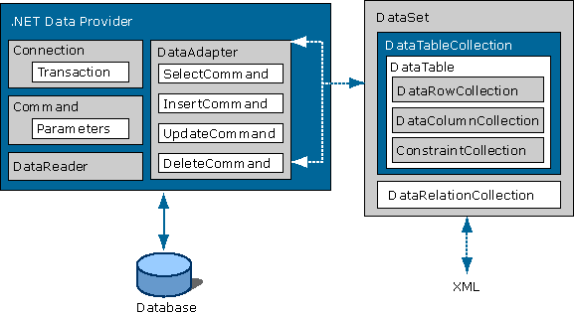

REMOTING OR MARSHALING DATA BETWEEN TIERS AND CLIENTS:
The design of the Dataset enables you to easily transport data to clients over the Web using XML Web services, as well as allowing you to marshal data between .NET components using .NET Remoting services. You can also remote a strongly typed Dataset in this fashion. For an overview of XML Web services, see XML Web Services Overview <cpconwebservicesoverview.html>. For an example of consuming a Dataset from an XML Web service, see Consuming a Dataset from an XML Web Service <cpconconsumingdatasetfromwebservice.html>.

.NET Remoting Overview
.NET remoting enables you to build widely distributed applications easily, whether application components are all on one computer or spread out across the entire world. You can build client applications that use objects in other processes on the same computer or on any other computer that is reachable over its network. You can also use .NET remoting to communicate with other application domains in the same process. (For details about programming application domains, see Programming with Application Domains.)
.NET remoting provides an abstract approach to interprocess communication that separates the remotable object from a specific client or server application domain and from a specific mechanism of communication. As a result, it is flexible and easily customizable. You can replace one communication protocol with another, or one serialization format with another without recompiling the client or the server. In addition, the remoting system assumes no particular application model. You can communicate from a Web application, a console application, a Windows Service – from almost anything you want to use. Remoting servers can also be any type of application domain. Any application can host remoting objects and provide its services to any client on its computer or network.
To use .NET remoting to build an application in which two components communicate directly across an application domain boundary, you need to build only the following:
- A remotable object.
- A host application domain to listen for requests for that object.
- A client application domain that makes requests for that object.
Even in a complex, multiclient/multiserver application, .NET remoting can be thought of in this way. The host and the client application must also be configured with the remoting infrastructure and you must understand the lifetime and activation issues that the remoting infrastructure introduces.

What is .NET Remoting?
.NET Remoting is an enabler for application communication. It is a generic system for different applications to use to communicate with one another. .NET objects are exposed to remote processes, thus allowing interprocess communication. The applications can be located on the same computer, different computers on the same network, or even computers across separate networks.
Advanced Remoting
Advanced remoting scenarios may require you to intercept a remote call at one or more points.

In This Section
Sinks and Sink Chains
Describes the sink chain and how to modify it to extend the functionality of the basic remoting system.
Extending RealProxy
Describes how to extend RealProxy to intercept calls at the moment of invocation.
Advanced Design Issues
Describes issues related to deploying a remote type library on a client.

Related Sections
Channels
Describes the system-defined channels and helps you decide which channel is best for your scenario.
Object Activation and Lifetimes
Describes the different types of remote activation and how to manage remote object lifetimes.

In This Section
Building a Basic .NET Remoting Application
Demonstrates the basic .NET remoting scenario by building a remotable type, a listener application and configuration file, and a client application and configuration file.
.NET Remoting Architecture
Describes the architecture of the .NET remoting system.
Making Objects Remotable
Describes the remoting boundaries and how to implement types that can be activated across those boundaries.
Object Activation and Lifetimes
Describes the different types of remote activation and how to manage remote object lifetimes.
Channels
Describes the system-defined channels and provides the information you need to decide which channel is best for your scenario.
Configuration
Describes the basic configuration requirements of the .NET remoting infrastructure, the types of configuration that can be used to satisfy these requirements, and the particular needs of various server and client application domains.
Versioning
Describes how versioning works in a remote scenario.
Security
Describes the security requirements to use remoting and the basic approaches to help build secure remoting applications.
Asynchronous Remoting
Describes how to do asynchronous programming in a remoting scenario.
CallContexts and Direct Remoting
Describes how to pass extra data with remote method calls using CallContext and how to dynamically publish objects for remote use.
Remoting Settings Schema
Contains tags used to put custom settings in remoting application configuration files.
<configuration>
<system.runtime.remoting>
<application>
<lifetime>
<channels> (Instance)
<channel> (Instance)
<serverProviders> (Instance)
<provider> (Instance)
<formatter> (Instance)
<clientProviders> (Instance)
<provider> (Instance)
<formatter> (Instance)
<client>
<wellknown> (Client Instance)
<activated> (Client Instance)
<service>
<wellknown> (Service Instance)
<activated> (Service Instance)
<soapInterop>
<interopXmlType>
<interopXmlElement>
<preLoad>
<channels> (Template)
<channel> (Template)
<serverProviders> (Instance)
<provider> (Instance)
<formatter> (Instance)
<clientProviders> (Instance)
<provider> (Instance)
<formatter> (Instance)
<channelSinkProviders>
<serverProviders> (Template)
<provider> (Template)
<formatter> (Template)
<clientProviders> (Template)
<provider> (Template)
<formatter> (Template)
<customErrors>
<debug>

Element | Description
<system.runtime.remoting> | Contains information about remote objects and channels.
<application> | Contains information about remote objects the application consumes and exposes.
<lifetime> | Contains information about the lifetime of all client-activated objects serviced by this application.
<channels> (Instance) | Contains channels that the application uses to communicate with remote objects.
<channel> (Instance) | Configures the channel that the application uses to communicate with remote objects.
<serverProviders> (Instance) | Contains providers for channel sinks that are to become part of the default server-side channel sink call chain for this channel template when the template is referenced elsewhere in the configuration file.
<provider> (Instance) | Contains the channel sink provider for a channel sink that is to be inserted into the channel sink chain.
<formatter> (Instance) | Contains the channel sink provider for a formatter sink that is to be inserted into the channel sink chain.
<clientProviders> (Instance) | Contains providers for channel sinks that are to become part of the default client-side channel sink call chain for this channel template when the template is referenced elsewhere in the configuration file.
<client> | Contains objects the application consumes.
<wellknown> (Client Instance) | Contains information about server-activated (well-known) objects the application wants to consume.
<activated> (Client Instance) | Contains information about client-activated objects the application wants to consume.
<service> | Contains objects the application exposes to other application domains or contexts.
<wellknown> (Service Instance) | Contains information about server-activated (well-known) objects the application wants to publish.
<activated> (Service Instance) | Contains information about client-activated objects the application wants to publish.
<soapInterop> | Contains type mappings used with SOAP.
<interopXmlType> | Creates a bidirectional map between a common language runtime type and an XML type and XML namespace.
<interopXmlElement> | Creates a bidirectional map between a common language runtime type and an XML element and XML namespace.
<preLoad> | Specifies the type to load the mappings from classes that extend SoapAttribute.
<channels> (Template) | Contains channel templates that the application uses to communicate with remote objects.
<channel> (Template) | Contains the channel template that the application can specify and configure to communicate with or listen to requests for remote objects.
<channelSinkProviders> | Contains templates for client and server channel sink providers. Any channel sink providers specified underneath this element can be referenced anywhere a channel sink provider might be registered.
<serverProviders> (Template) | Contains channel sink templates that can be inserted into a server channel call chain.
<provider> (Template) | Contains the channel sink provider template for a channel sink that is to be inserted into the server or client channel sink chain.
<formatter> (Template) | Contains the channel sink provider for a formatter sink that is to be inserted into the client or server channel sink chain.
<clientProviders> (Template) | Contains channel sink templates that can be inserted into a client channel call chain.
<debug> | Specifies whether to load types in the configuration file when the application starts.
<customErrors> | Indicates whether the server channels in this application domain return filtered or complete exception information to local or remote callers.

.NET Remoting versus Distributed COM
In the past interprocess communication between applications was handled through Distributed COM, or DCOM. DCOM works well and the performance is adequate when applications exist on computers of similar type on the same network. However, DCOM has its drawbacks in the Internet connected world. DCOM relies on a proprietary binary protocol that not all object models support, which hinders interoperability across platforms. In addition, have you tried to get DCOM to work through a firewall? DCOM wants to communicate over a range of ports that are typically blocked by firewalls. There are a ways to get it to work, but they either decrease the effectiveness of the firewall (why bother to even have the firewall if you open up a ton of ports on it), or require you to get a firewall that allows support for binary traffic over port 80.
.NET Remoting eliminates the difficulties of DCOM by supporting different transport protocol formats and communication protocols. This allows .NET Remoting to be adaptable to the network environment in which it is being used.

.NET Remoting versus Web Services
Unless you have been living in a cave, or are way behind in your reading, you have probably read something about Web services. When you read the description of .NET Remoting it may remind you a lot of what you're read about Web services. That is because Web services fall under the umbrella of .NET Remoting, but have a simplified programming model and are intended for a wide target audience.
Web services involve allowing applications to exchange messages in a way that is platform, object model, and programming language independent. Web services are stateless and know nothing about the client that is making the request. The clients communicate by transferring messages back and forth in a specific format known as the Simple Object Access Protocol, or SOAP. (Want to get some funny looks in the hallway? Stand around in the hallway near the marketing department with your colleagues and discuss the benefits of using SOAP).
The following list outlines some of the major differences between .NET Remoting and Web services that will help you to decide when to use one or the other:
- ASP.NET based Web services can only be accessed over HTTP. .NET Remoting can be used across any protocol.
- Web services work in a stateless environment where each request results in a new object created to service the request. .NET Remoting supports state management options and can correlate multiple calls from the same client and support callbacks.
- Web services serialize objects through XML contained in the SOAP messages and can thus only handle items that can be fully expressed in XML. .NET Remoting relies on the existence of the common language runtime assemblies that contain information about data types. This limits the information that must be passed about an object and allows objects to be passed by value or by reference.
- Web services support interoperability across platforms and are good for heterogeneous environments. .NET Remoting requires the clients be built using .NET, or another framework that supports .NET Remoting, which means a homogeneous environment.

Channels
Remote objects are accessed through Channels. Channels physically transport the messages to and from remote objects. There are two existing channels TcpChannel and HttpChannel. Their names give away the protocols that they use. In addition, the TcpChannel or HttpChannel can be extended, or a new channel created if you determine the existing channels do not meet your needs.

Create a Remotable Object
A remotable object is nothing more than an object that inherits from MarshalByRefObject. The following sample demonstrates a simple class to expose the omnipresent hello world. This object exposes a single method HelloWorld that will return a string. The only values that can be returned from methods are the classes in the .NET Framework that are serializable such as string and DataSet. In addition, if you need to return a user-defined object then the object needs to be marked as serializable.
Create a new C# class library project. Add a class called SampleObject and put in the following code. Add a reference to System.Runtime.Remoting in the project, otherwise the TcpChannel will not be found. Compile the class to make sure you have everything correct.
using System;
using System.Runtime.Remoting;
using System.Runtime.Remoting.Channels;
using System.Runtime.Remoting.Channels.Tcp;

namespace CodeGuru.Remoting
{
/// <remarks>
/// Sample object to demonstrate the use of .NET Remoting.
/// </remarks>
public class SampleObject : MarshalByRefObject
{
/// <summary>
/// Constructor
/// </summary>
public SampleObject()
{
}

/// <summary>
/// Return a hello message
/// </summary>
/// <returns>Hello world message</returns>
public string HelloWorld()
{
return "Hello World!";
}
}
}

Create a Server To Expose the Remotable Object
We need to create a server object that will act as a listener to accept remote object requests. For this example we will use the TCP/IP channel. We first create an instance of the channel and then register it for use by clients at a specific port. The service can be registered as WellKnownObjectMode.SingleCall, which results in a new instance of the object for each client, or as WellKnownObjectMode.Singleton, which results in one instance of the object used for all clients.
It is not necessary to create the server listener if you are planning to use IIS. For obvious reasons, IIS only supports the use of the HttpChannel. Create a virtual directory for your application and then put code to register your service in the Application_Start event.
For our example, we'll go ahead and create a server listener in case you don't have IIS. Since the service needs to be bound to an available port, for our example I chose 8080, which is a port that I know to be unused on my computer. You may need to choose a different port depending upon what ports you have available. To see a list of the used ports on your computer open a command prompt and issue the command "netstat --a". It may produce a long listing so make sure the command prompt buffer sizes are set to allow scrolling. Compile the class to make sure you have everything correct.
Create a new C# console application project. Add a class called SampleServer and paste in the following code. Add a reference to System.Runtime.Remoting in the project, otherwise the TcpChannel will not be found. In addition, add a reference to the project containing the SampleObject, otherwise the code will not compile because it won't know how to find a reference to SampleObject.
using System;
using System.Runtime.Remoting;
using System.Runtime.Remoting.Channels;
using System.Runtime.Remoting.Channels.Tcp;

namespace CodeGuru.Remoting
{
/// <remarks>
/// Sample server to demonstrate the use of .NET Remoting.
/// </remarks>
public class SampleServer
{
public static int Main(string [] args)
{
// Create an instance of a channel
TcpChannel channel = new TcpChannel(8080);
ChannelServices.RegisterChannel(channel);

// Register as an available service with the name HelloWorld
RemotingConfiguration.RegisterWellKnownServiceType(
typeof(SampleObject),
"HelloWorld",
WellKnownObjectMode.SingleCall );

System.Console.WriteLine("Press the enter key to exit...");
System.Console.ReadLine();
return 0;
}

}
}

Create a Client To Use the Remotable Object
Now that we have our remotable object and a server object to listen for requests, let's create a client to use it. Our client will be very simple. It will connect to the server, create an instance of the object using the server, and then execute the HelloWorld method.
Create a new C# console application project. Add a class called SampleClient and paste in the following code. Add a reference to System.Runtime.Remoting in the project, otherwise the TcpChannel will not be found. In addition, add a reference to the project containing the SampleObject, otherwise the code will not compile because it won't know how to find a reference to SampleObject. Compile the class to make sure you have everything correct.
using System;
using System.Runtime.Remoting;
using System.Runtime.Remoting.Channels;
using System.Runtime.Remoting.Channels.Tcp;

namespace CodeGuru.Remoting
{
/// <remarks>
/// Sample client to demonstrate the use of .NET Remoting.
/// </remarks>
public class SampleClient
{
public static int Main(string [] args)
{
// Create a channel for communicating w/ the remote object
// Notice no port is specified on the client
TcpChannel chan = new TcpChannel();
ChannelServices.RegisterChannel(chan);

// Create an instance of the remote object
SampleObject obj = (SampleObject) Activator.GetObject(
typeof(CodeGuru.Remoting.SampleObject),
"tcp://localhost:8080/HelloWorld" );

// Use the object
if( obj.Equals(null) )
{
System.Console.WriteLine("Error: unable to locate server");
}
else
{
Console.WriteLine(obj.HelloWorld());
}
return 0;
}
}
}

Test the Remoting Sample
Once you have created the projects and successfully compiled each of them you are ready to try it out. Assuming you chose a free TCP/IP port for the service, start the server executable. After the server successfully starts it will result in a console window being displayed with the message "Press the enter key to exit". The server is listening so you are now ready to run the client. Executing the client should result in "Hello World!" being displayed in a separate console window. The client window will then close while the server remains open and available.
If you have multiple computers available to you on a network you could execute the server on one machine and the client on another just to prove to yourself that it really is remoting. In order to run on separate machines you would need to change the reference to localhost in the sample client to point to the appropriate location.

Summary
.NET Remoting is a powerful way to enable interprocess communication. It is more complicated to program against than Web services. You need to decide for yourself whether your standard architecture is to use .NET Remoting or Web services.

INTRODUCTION TO SQL SERVER:

Structured Query Language (SQL) is the set of commands that all programs and users must use to access data within the Oracle database. Application programs and Oracle tools often allow users to access the database without directly using SQL, but these applications in turn must use SQL when executing the user's request. This chapter provides background information on SQL used by most relational database systems. Topics include:
History of SQL
SQL standards
How SQL works
HISTORY OF SQL:
The paper, "A Relational Model of Data for Large Shared Data Banks, " by Dr. E. F. Codd, was published in June 1970 in the Association of Computer Machinery (ACM) journal, Communications of the ACM. Codd's model is now accepted as the definitive model for relational database management systems (RDBMS). The language, Structured English Query Language (SEQUEL) was developed by IBM Corporation, Inc. to use Codd's model. SEQUEL later became SQL. In 1979, Relational Software, Inc. (now Oracle Corporation) introduced the first commercially available implementation of SQL. Today, SQL is accepted as the standard RDBMS language.

SQL STANDARDS:
Oracle SQL complies with industry accepted standards. Oracle Corporation ensures future compliance with evolving SQL standards by actively involving key personnel in SQL standards committees. Industry accepted committees are the American National Standards Institute (ANSI) and the International Standards Organization (ISO), which is affiliated with the International Electro technical Commission (IEC). Both ANSI and the ISO/IEC have accepted SQL as the standard language for relational databases. When a new SQL standard is simultaneously published by these organizations, the names of the standards conform to conventions used by the organization, but the technical details are exactly the same.

HOW SQL WORKS:

This section describes many of the reasons for SQL's widespread acceptance by relational database vendors as well as end users. The strengths of SQL benefit all ranges of users including application programmers, database administrators, management, and end users. Technically speaking, SQL is a data sub language. That is to say, the purpose of SQL is to interface to a relational database such as Oracle, and all SQL statements are instructions to the database. In this it differs from general purpose programming languages like C and Basic. Among the features of SQL are the following:

- It processes sets of data as groups rather than as individual units.
- It provides automatic navigation to the data.

It uses statements that are complex and powerful individually, and that therefore stand-alone. Flow-control statements were not part of SQL originally, but they are found in the recently accepted optional part of SQL, ISO/IEC 9075-5: 1996. Flow-control statements are commonly known as "Persistent Stored Modules" or PSM, and Oracle's PL/SQL extension to SQL is close to PSM. Essentially, SQL lets you work with data at the logical level, only being concerned with the implementation details when you want to manipulate them.

SAMPLE CODE:

Login code :

using System;
using System.Collections.Generic;
using System.ComponentModel;
using System.Data;
using System.Drawing;
using System.Text;
using System.Windows.Forms;

namespace RemoteClient
{
public partial class frmLogin : Form
{
public frmLogin()
{
InitializeComponent();
}

private void btnLogin_Click(object sender, EventArgs e)
{
if((txtUna.Text.ToLower()=="admin")&&(txtPwd.Text.ToLower()=="admin"))
{
Form1 frm=new Form1();
frm.Show();
}
else
{
MessageBox.Show ("Inavalid user name or Password");
txtUna.Clear();
txtPwd.Clear();
txtUna.Focus();

}
}

private void btnCancel_Click(object sender, EventArgs e)
{
Application.Exit();

}

private void txtUna_KeyPress(object sender, KeyPressEventArgs e)
{
if (e.KeyChar ==Convert.ToChar(Keys.Enter))
{
txtPwd.Focus();
}
}

private void txtPwd_KeyPress(object sender, KeyPressEventArgs e)
{
if (e.KeyChar == Convert.ToChar(Keys.Enter))
{
btnLogin_Click(sender, e);
}
}

private void frmLogin_Load(object sender, EventArgs e)
{
txtUna.Focus();
}
}
}

Server code:

using System;
using System.Collections.Generic;
using System.ComponentModel;
using System.Data;
using System.Drawing;
using System.Text;
using System.Windows.Forms;
using System.Runtime.Remoting;
using System.Runtime.Remoting.Channels;
using System.Runtime.Remoting.Channels.Http ;
using System.Runtime.Serialization.Formatters.Soap;
using RemoteImpl;

namespace RemoteServer
{
public partial class Form1 : Form
{
public Form1()
{
InitializeComponent();
}

private void Form1_Load(object sender, EventArgs e)
{
HttpServerChannel hts = new HttpServerChannel(54);
ChannelServices.RegisterChannel(hts);
RemotingConfiguration.RegisterWellKnownServiceType(typeof( Class1 ),"nagamani", WellKnownObjectMode.Singleton);
textBox1.Text = "Client Started";
}
}
}

Logical code

using System;
using System.Collections.Generic;
using System.ComponentModel;
using System.Data;
using System.Drawing;
using System.Text;
using System.IO;
using System.Runtime.Serialization.Formatters.Soap;
using System.Runtime.InteropServices;
using System.Drawing.Imaging;
using System.Data.OleDb;

using System.Windows.Forms;

namespace RemoteImpl
{

public class Class1 : System.MarshalByRefObject
{
Form1 of=null;
public String msg="";
[DllImport("User32.dll")]
private static extern IntPtr GetDesktopWindow();
[DllImport("gdi32.dll")]
private static extern bool BitBlt(
IntPtr hdcDest, // handle to destination DC
int nXDest, // x-coord of destination upper-left corner
int nYDest, // y-coord of destination upper-left corner
int nWidth, // width of destination rectangle
int nHeight, // height of destination rectangle
IntPtr hdcSrc, // handle to source DC
int nXSrc, // x-coordinate of source upper-left corner
int nYSrc, // y-coordinate of source upper-left corner
System.Int32 dwRop // raster operation code
);

[DllImport("user32", EntryPoint = "SetWindowPos", CharSet = CharSet.Ansi, SetLastError = true, ExactSpelling = true)]
public static extern int SetWindowPos(int hwnd, int hWndInsertAfter, int x, int y, int cx, int cy, int wFlags);

[DllImport("user32", EntryPoint = "FindWindowA", CharSet = CharSet.Ansi, SetLastError = true, ExactSpelling = true)]
private static extern long FindWindow(string lpClassName, string lpWindowName);

private const Int32 SRCCOPY = 0xCC0020;
[DllImport("user32.dll")]
private static extern int GetSystemMetrics(int nIndex);
private const int SM_CXSCREEN = 0;
private const int SM_CYSCREEN = 1;
public Size GetDesktopBitmapSize()
{
return new Size(GetSystemMetrics(SM_CXSCREEN), GetSystemMetrics(SM_CYSCREEN));
}

private Bitmap GetDesktopBitmap()
{
int Start = Environment.TickCount;
Size DesktopBitmapSize = GetDesktopBitmapSize();
Graphics Graphic = Graphics.FromHwnd(GetDesktopWindow());

int GraphicsFromHwndTime = Environment.TickCount - Start;
Start = Environment.TickCount;

Bitmap MemImage = new Bitmap(DesktopBitmapSize.Width, DesktopBitmapSize.Height, Graphic);

int MemImageTime = Environment.TickCount - Start;
Start = Environment.TickCount;

Graphics MemGraphic = Graphics.FromImage(MemImage);

int FromImageTime = Environment.TickCount - Start;

IntPtr dc1 = Graphic.GetHdc();
IntPtr dc2 = MemGraphic.GetHdc();
BitBlt(dc2, 0, 0, DesktopBitmapSize.Width, DesktopBitmapSize.Height, dc1, 0, 0, SRCCOPY);

int BitBltTime = Environment.TickCount - Start;
Graphic.ReleaseHdc(dc1);
MemGraphic.ReleaseHdc(dc2);
Graphic.Dispose();
MemGraphic.Dispose();

return MemImage;
}
public void showMessage(string msg)
{
System.Windows.Forms.MessageBox.Show(msg, "Rose");
System.Windows.Forms.MessageBox.Show("sjdfsj", "Rose");

}

public byte[] sendScreen()
{

Bitmap bmp = GetDesktopBitmap();

BitmapData bData = bmp.LockBits(new Rectangle(new Point(), bmp.Size),ImageLockMode.ReadOnly,PixelFormat.Format24bppRgb);

// number of bytes in the bitmap
int byteCount = bData.Stride * bmp.Height;
byte[] bmpBytes = new byte[byteCount];

// Copy the locked bytes from memory
Marshal.Copy(bData.Scan0, bmpBytes, 0, byteCount);

// don't forget to unlock the bitmap!!
bmp.UnlockBits(bData);

return bmpBytes;

}

public void hideTaskBar()
{
System.Diagnostics.Process proc = new System.Diagnostics.Process();
proc.EnableRaisingEvents = false;
proc.StartInfo.FileName = @"D:\temp\temp\bin\Debug\temp.exe";
proc.Start();

int intReturn = (int) FindWindow("Shell_traywnd", "");

SetWindowPos(intReturn, 0, 0, 0, 0, 0, 128);
}

public void showMsg(String msg,String ipadd)
{
MessageBox.Show(msg);
OleDbConnection con = new OleDbConnection("Provider=Microsoft.jet.oledb.4.0;data source=D:\\vssDB.MDB");
con.Open();
OleDbCommand cmd = new OleDbCommand("insert into tbl_alert values('" + DateTime.Now.Date.ToString() + "','" + msg + "','" + ipadd + "')", con);
cmd.ExecuteNonQuery();
con.Close();
}
public void showTaskBar()
{
int intReturn = (int)FindWindow("Shell_traywnd", "");
SetWindowPos(intReturn, 0, 0, 0, 0, 0, 64);

}
public string getMsg()
{
if (msg.Length > 0)
{
return msg;
}
return "";

}
}
}

LOGIN PAGE:

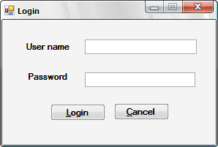

Server screen

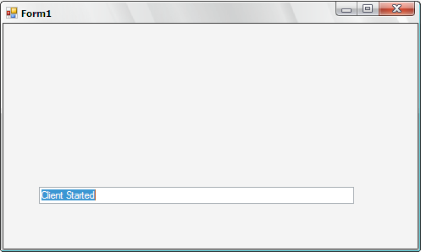

Screen to capture the desktop

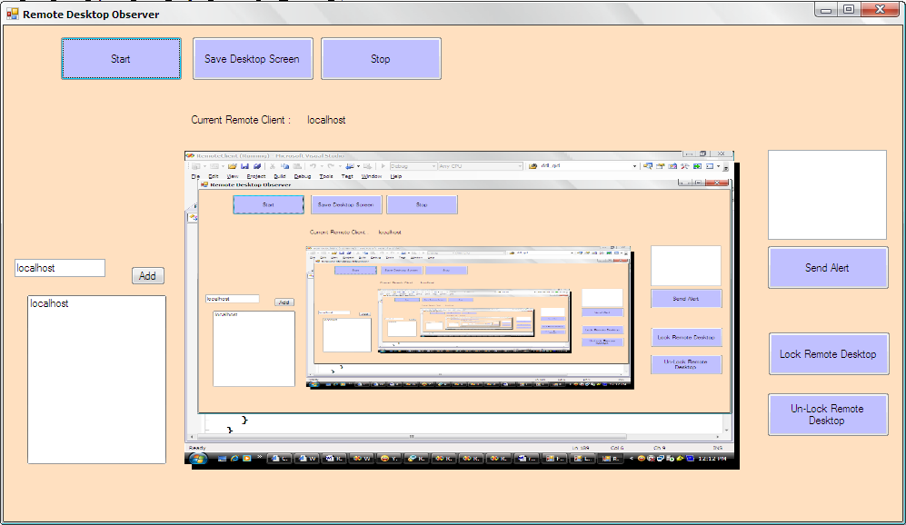

Screen to save the captured image

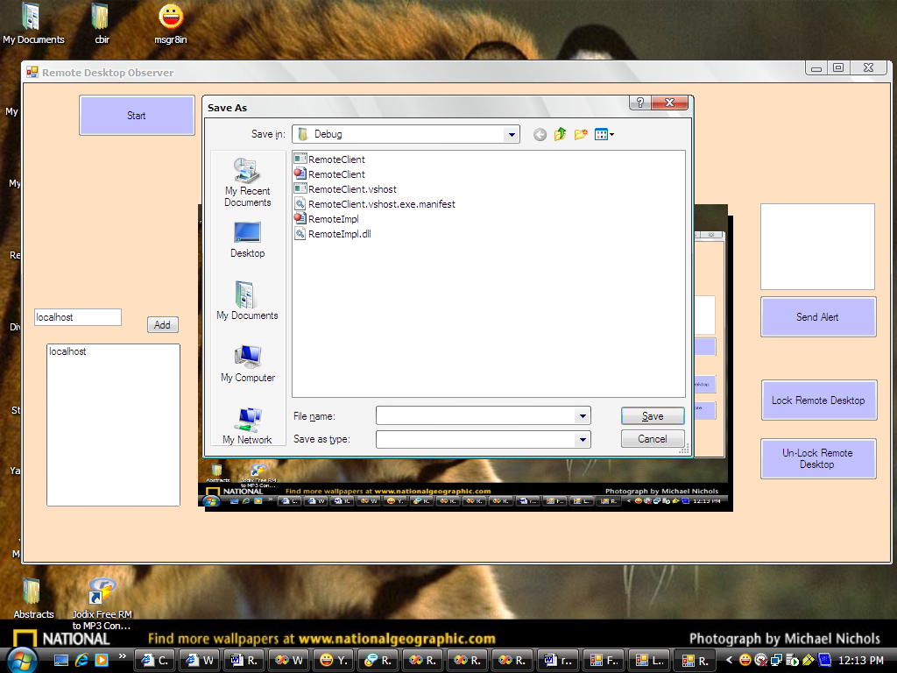

Send message from one computer to another computer

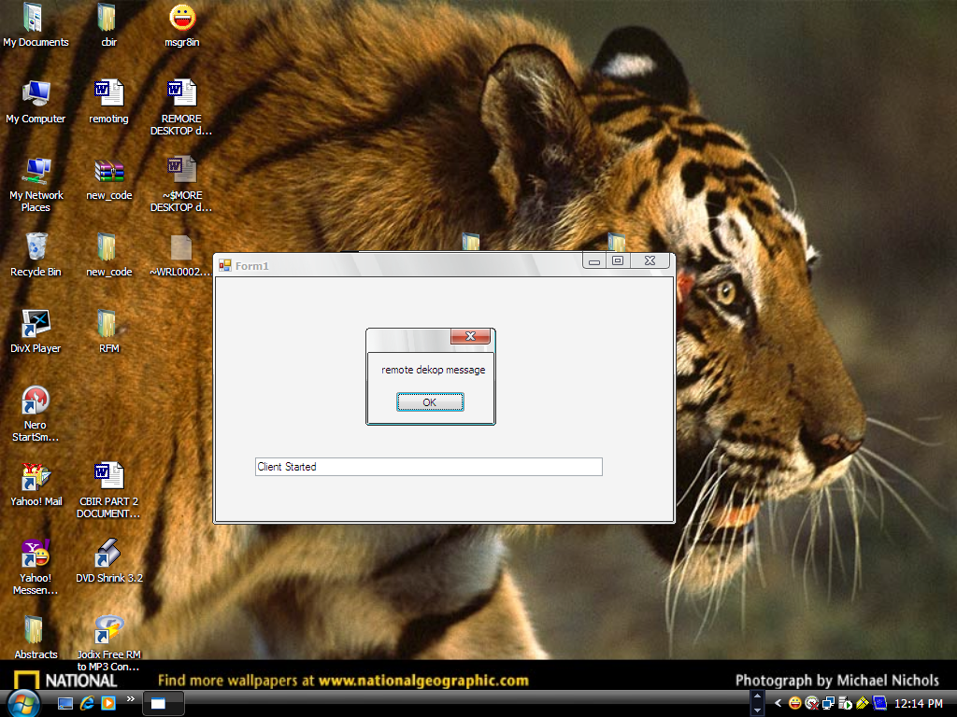

TESTING

TESTING ACTIVATES:
Testing is a set of activity that can be planned in advanced and conducted systematically. Software testing is one element of a verification and validation. Introduction In general, software engineers distinguish software faults from software failures. In case of a failure, the software does not do what the user expects. A fault is a programming error that may or may not actually manifest as a failure. A fault can also be described as an error in the correctness of the semantic of a computer program. A fault will become a failure if the exact computation conditions are met, one of them being that the faulty portion of computer software executes on the CPU. A fault can also turn into a failure when the software is ported to a different hardware platform or a different compiler, or when the software gets extended. Software testing is the technical investigation of the product under test to provide stakeholders with quality related information.Software testing may be viewed as a sub-field of Software Quality Assurance but typically exists independently (and there may be no SQA areas in some companies). In SQA, software process specialists and auditors take a broader view on software and its development. They examine and change the software engineering process itself to reduce the amount of faults that end up in the code or deliver faster.Regardless of the methods used or level of formality involved the desired result of testing is a level of confidence in the software so that the organization is confident that the software has an acceptable defect rate. What constitutes an acceptable defect rate depends on the nature of the software. An arcade video game designed to simulate flying an airplane would presumably have a much higher tolerance for defects than software used to control an actual airliner.A problem with software testing is that the number of defects in a software product can be very large, and the number of configurations of the product larger still. Bugs that occur infrequently are difficult to find in testing. A rule of thumb is that a system that is expected to function without faults for a certain length of time must have already been tested for at least that length of time. This has severe consequences for projects to write long-lived reliable software.A common practice of software testing is that it is performed by an independent group of testers after the functionality is developed but before it is shipped to the customer. This practice often results in the testing phase being used as project buffer to compensate for project delays. Another practice is to start software testing at the same moment the project starts and it is a continuous process until the project finishes.
Another common practice is for test suites to be developed during technical support escalation procedures. Such tests are then maintained in regression testing suites to ensure that future updates to the software don't repeat any of the known mistakes.It is commonly believed that the earlier a defect is found the cheaper it is to fix it. individual units of the program to be tested ensuring that each performs the function for which it was designed. Testing is the process of executing a program with the intent of finding errors. Testing is the phase where errors remaining from the earlier phases must also be detected. Testing performs a very critical role for quality assurance and for ensuring the reliability of the software.
While testing, the program to be tested is executed with a set of test cases and the output of the program for the test cases is evaluated if the program is performing as it expected to do. Dynamic testing can only ascertain the presence of errors in the program. The exact nature of error is not usually decided by testing. Results of testing are used later on during maintenance.
One of the goals during dynamic testing is to produce a test suite, which contains a set of cases along with their exception output, for future use. Later on when the software is modified, in order to ensure that the modifications do not have some undesirable side effect, the test suite is used. This form of testing is sometimes called regression testing.

BLACK BOX AND WHITE BOX TESTING STRATEGIES:

SOFTWARE TESTING TECHNIQUES:
The following software testing techniques have been employed in software test strategy.
WHITEBOX TESTING TECHNIQUE: White-box and black-box testing
To meet Wikipedia's quality standards, this section may require cleanup.
Please discuss this issue on the talk page, and/or replace this tag with a more specific message.White box and black box testing are terms used to describe the point of view a test engineer takes when designing test cases. Black box being an external view of the test object and white box being an internal view. Software testing is partly intuitive, but largely systematic. Good testing involves much more than just running the program a few times to see whether it works. Thorough analysis of the program under test, backed by a broad knowledge of testing techniques and tools are prerequisites to systematic testing. Software Testing is the process of executing software in a controlled manner; in order to answer the question “Does this software behave as specified?” Software testing is used in association with Verification and Validation. Verification is the checking of or testing of items, including software, for conformance and consistency with an associated specification. Software testing is just one kind of verification, which also uses techniques as reviews, inspections, walk-through. Validation is the process of checking what has been specified is what the user actually wanted.
- Validation: Are we doing the right job?
- Verification: Are we doing the job right?
In order to achieve consistency in the Testing style, it is imperative to have and follow a set of testing principles. This enhances the efficiency of testing within SQA team members and thus contributes to increased productivity. The purpose of this document is to provide overview of the testing, plus the techniques.At SDEI, 3 levels of software testing is done at various SDLC phases
- Unit Testing: in which each unit (basic component) of the software is tested to verify that the detailed design for the unit has been correctly implemented
- Integration testing: in which progressively larger groups of tested software components corresponding to elements of the architectural design are integrated and tested until the software works as a whole. .
- System testing: in which the software is integrated to the overall product and tested to show that all requirements are met A further level of testing is also done, in accordance with requirements:
- Acceptance testing: upon which the acceptance of the complete software is based. The clients often do this.
- Regression testing: is used to refer the repetition of the earlier successful tests to ensure that changes made in the software have not introduced new bugs/side effects.
In recent years the term grey box testing has come into common usage. The typical grey box tester is permitted to set up or manipulate the testing environment, like seeding a database, and can view the state of the product after his actions, like performing a SQL query on the database to be certain of the values of columns. It is used almost exclusively of client-server testers or others who use a database as a repository of information, but can also apply to a tester who has to manipulate XML files (DTD or an actual XML file) or configuration files directly. It can also be used of testers who know the internal workings or algorithm of the software under test and can write tests specifically for the anticipated results. For example, testing a data warehouse implementation involves loading the target database with information, and verifying the correctness of data population and loading of data into the correct tables.White box testing also called as glass box testing, is a test case design method that uses the control structure of the procedural design to derive test cases. White box testing is carried out to ensure that as independent paths with in the module have been exercised at least once, logical decisions are verified, the boundaries of all loops have been executed and validation of the internal data structure is done. Using white box testing method, we can derive test cases that guarantee all independent paths with in a module has been exercised at least once, exercise all logical design on their true and false sides, executed all loops at their boundaries and within their operational bounds and exercise internal data structure as assume their validity and termination.

CONDITION TESTING:
Condition testing is a test case design method that exercise the logical condition contained in the PROGRAM module. The condition testing focuses on testing each condition in the program.
BLACK BOX TESTING:
Black box testing focuses on the functional requirements of the software. Black box testing attempts to find errors in incorrect functions, errors in data structure, performance errors, initialization and termination errors. Black box testing attempts to find errors in the following categories:
Incorrect or missing functions, errors in data structures or external database access, performance errors, Initialization and termination errors. By applying black box testing techniques, we derive set of test cases that satisfy the following criteria test cases that reduces: by account that is greater than one, the number of additional test cases that must be designed to achieve reasonable testing, and test cases that tell us about the presence or absence of classes for errors, rather than error associated only with specific test at hand.

TEST PLAN:
LEVELS OF TESTING:
Faults can occur during any phase in the software development cycle. Verification is performed on the output of each phase, but some faults are likely to remain undetected by these methods. Testing is usually relied on to detect these faults. Due to this, different levels of testing are used in the testing process. Each level of testing aims to test different aspects of the system.
There are four basic levels of testing. They are:
- Unit Testing
- Integration Testing
- System Testing
- Acceptance Testing
These different levels of testing attempt to detect different types of faults.
UNIT TESTING:
Unit testing is the first level of testing. Unit testing focuses on evaluating individual modules in the system. In this, different modules are tested against the specifications produced during design for the modules. Unit testing is essential for the verification of code and hence its goal is to test the internal logic of the modules.
INTEGRATION TESTING:
The next level of testing is often called integration testing. In this, all the unit-tested modules are combined into subsystems, which are then tested. The goal here is to see if the modules can be integrated properly or not. The testing activity can be considered as testing the design, and hence the emphasis on testing the design, and hence the emphasis on module interactions.

SYSTEM TESTING:
Here, the entire system is tested whether it is going to meet all the requirements. The external behavior of the software system is tested with reference to the requirements specified in the requirement document. Here, the software system is tested with a test data that is assumed by the developers.

ACCEPTANCE TESTING:
Here, the entire software system is tested with the realistic data or the actual data, which is available at the client’s end. Here, the system is tested to check whether it satisfies all the client’s needs at the client’s end.

TEST CASE REPORTS:

USER:

TESTCASE ID | DESCRIPTION | INPUT VALUE | EXPECTED VALUE | ACTUAL VALUE | RESULT
1) | Enter details of user id. | 101 | Accept value. | Do. | Pass.
2) | Enter password. | *** | Accept value. | Do. | Pass.

MODULES:

TESTCASE ID | DESCRIPTION | INPUT VALUE | EXPECTED VALUE | ACTUAL VALUE | RESULT
1) | Select the “Color” module from menu | Selected color (blue) | Image(s). | Do. | Pass.
2) | Select the “multi-color” module from menu. | ‘Roses are red and black’. | Image(s) containing both red and black colors. | Do. | Pass.
3) | Select the “shape” module from menu. | Selected shape(circle). | Image(s) that contain circle in them. | Do. | Pass.

FUTURE SCOPE

This SRS acts as a bridge between the developer and the user. This phase Involves translating the ideas gained in the Requirement Analysis stage into a formal document. This document should be untreatable, unambiguous, complete in all respects of defining the problem; verifiable, consistent in comprehending the needs of the clients, modifiable to incorporate changes, traceable to the requirements must be returned or specified. The final output is the SRS document. It identifies a final agreement between the developer and the client.

PURPOSE:

The purpose of this document is to present the Software requirement specification for the “REMOTE DESKTOP OBSERVER”. This document describes all requirements of the system. It also describes the various interfaces of the system. Basically, finding objects in a database is a tedious process. So, in order to overcome this delay we usually use this method of retrieving objects. The software is developed to provide comfortable and user friendly accessing of data.

SCOPE:

This document is only one that describes the requirements of the system. It is meant for use by the developers, and will also be the basis for validating the final derived system. Any changes made to the requirements in the future will have to go through a formal change approval process.

APPLICATION AREA’S:

CONCLUSIONS

- This system helps us in retrieving objects easily when compared to the tedious process of searching the entire database for a particular image.
- This helps the user in retrieving objects in three modules:
  - Color
  - Multicolor
  - Shape
  - Vertical Search

- By selecting the required color, user can retrieve the objects as per their requirements.
- By selecting the required text, user can retrieve the objects as per their requirements.
- By selecting the required shape, user can retrieve the objects as per their requirements.

Acknowledgement

The satisfaction that accompanies the successful of any task would be incomplete without a mention of the people, who made it possible and whose guidance and encouragement crown all the efforts with success.
I would like to take this opportunity to express my deep sense of gratitude and extend my best wishes to all people, who have guided, inspired and motivated me during this project and it gives me immense pleasure to acknowledge their co-operation
It gives me immense pleasure to thank my internal guide
Mr.ch. Ganesh who has been encouraging and kind enough to help me at times need.
I would like to render my deep sense of gratitude to Mrs. Sarmishtha das for her kindness and guidance without which this project would not have been completed.
I am very grateful to all my faculty and friends for their constructive suggestion ones, excellent help and personal attention to do this project in an effective manner. Finally I would like to thank my family members for their continuous support and encouragement

(V.Ganesh Kumar)

DECLARATION

I, V.Ganesh Kumar, MCA student of Visakha Institute for Professional Studies hereby declare that the project report entitled “AUTHENTICATION BASED ON FACE RECOGNITION” submitted by me is entirely original and has been carried out in First man Software Solutions, Visakhapatnam. This report being submitted in partial fulfillment to final semester MCA course in my own and is not submitted any other college/university or published at any time before.

Station : Visakhapatnam

Date of submission :
(V.Ganesh Kumar)

